N301-- How to bind the IP address with your device
Note: This article will guide you how to bind the IP address with your device and the steps as below.

Step 1: Connect your computer to the LAN port. Power on the N301.

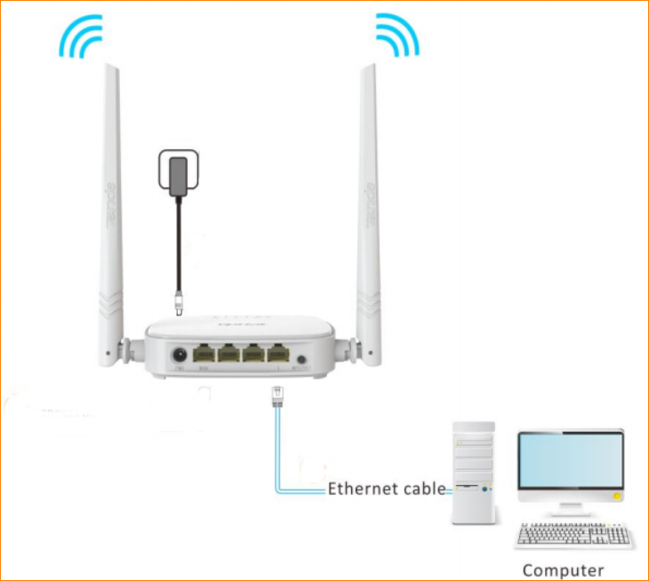

You can also use your smartphone to configure the router.

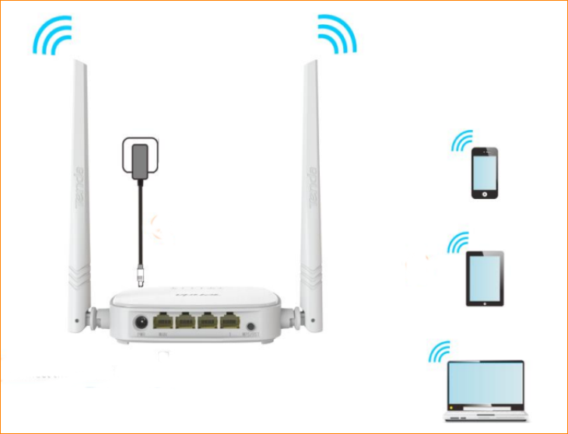

Step 2: Open a Web Browser -> Type 192.168.0.1 in the address bar -> Press Enter



Step3: Bind one IP with your device. Type the IP address you want to bind with your device in “IP Address” bar, and type the MAC address in “MAC Address” bar, and click the “+” to apply it, and then click “OK” to save these settings.

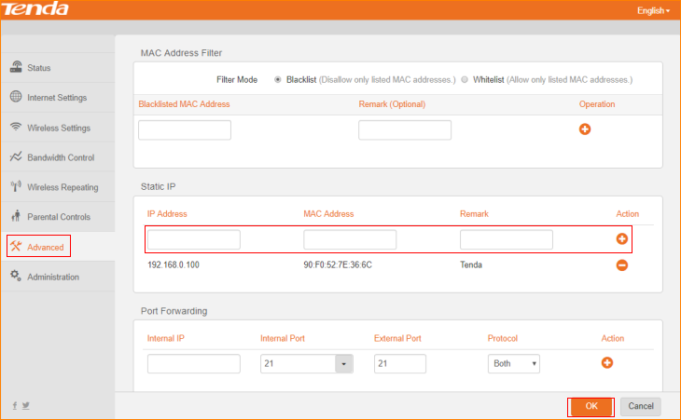

Step 4: Then you can see the IP address bound your device with its MAC address.

